

Ref: 2645/Circular/07.10

1 July 2010

All Residents
No.9, 11,15 Ardmore Park, Singapore

Dear Residents,

SERVICING SCHEDULE FOR THE MONTH OF JULY 2010

Please be informed of the following servicing schedules for the lifts/fire protection system/pest control/recycling for the month of
JULY 2010.

S/No | Contractor | Services | Date | Time | Remarks
1 | B.S. Engineering Co Pte Ltd | Fire Protection | 21 July 2010 | 1300hrs to 1700hrs | Please do not be alarmed when the fire alarm is activated
2 | ABJ Pest Control Pte Ltd | Pest Control | 1, 8, 15, 22 & 29 July 2010 | Between 0930hrs to 1200hrs | Please close (seal) your bin chute hopper and windows tightly during the fumigation
3 | In-house | Collection of Recycle Materials | Daily | From 0800hrs to 0930hrs | Please place recyclable materials besides the service lift area for collection.
4. | Anchor Cleaning Agency Pte Ltd | Bin Chute Flushing | 3, 7, 10, 14, 17, 21, 24, 28 & 31 July 2010  (Every Wed & Sat) | From 1000hrs to 1200hrs | Please close your bin chute hopper during the flushing

Lift Maintenance Schedule
Blk No | Lift No | Date | Time | Remarks
Block 9 | Lobby Lift No 1  Lobby Lift No 2  Lobby Lift No 3  Lobby Lift No 4  Service Lobby Lift No 10 | 20 July 2010  20 July 2010  20 July 2010  20 July 2010  20 July 2010 | 1500hrs to 1630hrs  1630hrs to 1800hrs  0930hrs to 1200hrs  1230hrs to 1500hrs  1800hrs to 1930hrs | Kindly be reminded to bring along your rear door key during this period. Our security officer may fermax your unit for permission to test the operation of the lift to your floor.
Block 11 | Lobby Lift No 5  Lobby Lift No 6  Lobby Lift No 7  Lobby Lift No 8  Service Lobby Lift No 11 | 21 July 2010  21 July 2010  21 July 2010  21 July 2010  21 July 2010 | 0900hrs to 1030hrs  1030hrs to 1200hrs  1300hrs to 1430hrs  1430hrs to 1600hrs  1600hrs to 1730hrs | Kindly be reminded to bring along your rear door key during this period. . Our security officer may fermax your unit for permission to test the operation of the lift to your floor.
Block 13 | Club House P1 | 22 July 2010 | 1730hrs to 1900hrs
Block 15 | Lobby Lift No 9  Lobby Lift No 10  Lobby Lift No 11  Lobby Lift No 12  Service Lobby Lift No 12 | 22 July 2010  22 July 2010  22 July 2010  22 July 2010  22 July 2010 | 1300hrs to 1430hrs  1430hrs to 1600hrs  1600hrs to 1730hrs  1000hrs to 1100hrs  0930hrs to 1200hrs | Kindly be reminded to bring along your rear door key during this period. . Our security officer may fermax your unit for permission to test the operation of the lift to your floor.

Weekly high-level dusting and cleaning of the private lift cars schedule:
Day of Cleaning | Time | Block /Lift Nos. | Remarks
Monday  Tuesday  Wednesday | 10.00 am to 11.00 am  11.00 am to 12.00 pm  10.00 am to 11.00 am  11.00 am to 12.00 pm  10.00 am to 11.00 am  11.00 am to 12.00 pm | Blk 9/ Lift 1 & 2  Blk 9/ Lift 3 & 4  Blk 11/ Lift 5 & 6  Blk 11/ Lift 7 & 8  Blk 15/ Lift 9 & 10  Blk 15/ Lift 11 & 12 | Please do not be alarmed if you find a cleaner in the private lift during these times.

Please note that the servicing of private lift no. 3 and 4 and service lift no. 12 will take two and a half hours to complete, instead of the usual one and a half hours.

If you have any queries, please feel free to contact us at the management office telephone number 6733 0862. We apologise for any inconvenience caused.

Yours Faithfully,

Knight Frank Estate Management Pte Ltd
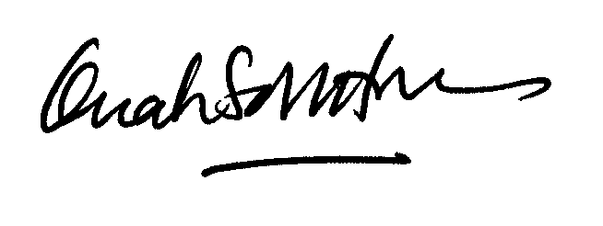

Ms Quah Soh Hoon
Ardmore Park General Manager
For and on behalf of The MCST Plan No. 2645

Our ref: Kfem/2645/Circular/qsh

1 July 2010

All Residents
9, 11, and 15 Ardmore Park

Dear Residents

Vandalism in MPC Area

Earlier this month, some children stripped off the rubber flooring at the Multi-Purpose Court behind Block 9. Please be informed that the destruction of common property within the estate is tantamount to vandalism. The Management takes a serious view of such wilful acts and will report these incidents to the Police. As the facilities are for your use and enjoyment, we urge that you instruct your family members to exercise due care when using them.
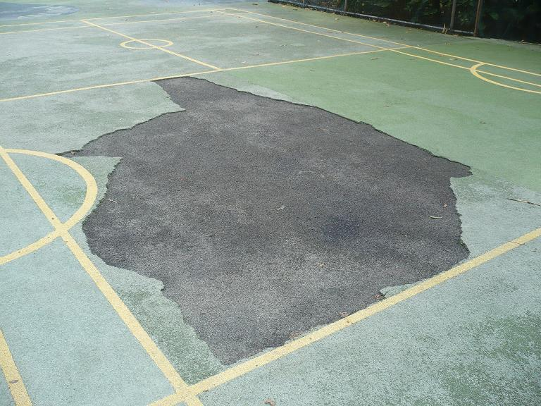

Climbing over the Front Perimeter Wall of Ardmore Park

A few of our residents’ children were seen climbing over the perimeter fence at the front of Block 11 in order to get into Ardmore Park. We would appreciate that residents and their family members use the proper entrance / exit points at the Main Entrance and Rear Gate to make your way in and out of Ardmore Park.

Car Washing in Washing Bays

With the increased in number of residents / drivers wishing to wash their vehicles in the morning, we would like to remind residents to remove your cars from the washing bays once you have finished washing your cars. If you do not wish to wash your vehicle early in the morning, kindly refrain from parking overnight at the washing bays. This will help free up the limited number of washing bays for use by other residents / drivers.

Private Lifts - Unsightly Dents (Stainless Steel Panels) And Scratched Marks (Wood Panels)

Lately, all of our private lifts have been scratched badly because residents transport their bicycles, skateboards, scooters and other hard bulky items through the lifts. We would like to remind residents to use the Service Lifts if you have to move such items in order to prevent any further accidental denting or scratching of the private lifts.

Publications and Magazines in the Clubhouse

The magazines, newspapers and publications in the Clubhouse are solely for your reading and enjoyment in the lobby of the Clubhouse Please do not take them out of the Clubhouse or to the gym or bring them home. Kindly place them back to their original positions after you have read them

Thank you for your kind attention and we appreciate your cooperation and assistance to create a conducive and safe environment for all concerned.

MCST Plan No 2645

